System REQUIREMENTS SPECIFICATION
for
eCMS - Tariff

Release No 1.0 – May 2021

document identification no 3 char SYS ID/ DOC CODE /NN/ V M.n)  for details refer to document mgmt stds | document title | status  (draft/ released ) | date of release | pages
eCMS /SRS/01/V1.0 | System Requirement Specifications For eCMS Tariff | Draft | 05.2021

 | role in the project | Name | signature | date  (dd-mm-yy)
Authors | Technical Team | Shrinivas Udagatti  Alvin Ian P Paule  Ramoji Lokam  Shubham Sharma
Reviewers | Project Lead | Sujit Patra
Approver | Project Manager | Raghavan Jaganathan

Endorsement by System Owner (internal)
 | Name | designation | signature | date  (dd-mm-yy)
Endorsed by System Owner | Chiew Lan Tan | Senior Director

release history
Release Number | associated change request number | Date (mm,yyyy) | Brief Summary of changes | Author
1.0 | First Release | 05.2021

Table of Contents
Table of Contents 3
Introduction 4
A. Definitions and Abbreviations 4
B. References 6
1. Functional Requirements 7
1.1 Tariff System Overview 7
1.1.1 Entity Hierarchy in Tariff system 7
1.2 HS Code Maintenance 9
1.2.1 Description 9
1.2.2 Design Considerations 9
1.3 Tax Types 11
1.3.1 Description 11
1.3.2 Ad Valorem 11
1.3.3 Specific Rate 12
1.3.4 Derive Cost 12
1.3.5 Additional Tax (Derive Tax) 12
1.4 HS Code Configurations 13
1.4.1 Description 13
1.4.2 Commercial Name 13
1.4.3 Unit of Measurement (UOM) 14
1.4.4 HS Code Tariff configuration 14
1.4.5 Prohibited 14
1.4.6 Restricted Goods 14
1.5 Customs Procedure Code (CPC) Maintenance 14
1.5.1 Description 14
Use case diagram for CPC 15
1.6 Agreements/Preferential Tariffs 15
1.6.1 Description 15
Use case diagram for Preferential Tariff 16
1.7 Duties and Taxes Computation Process 16
1.7.1 Description 16
1.7.2 Computation Process 17
1.8 Advance Rulings 21
1.8.1 Description 21
1.8.2 Process flow for application of Advance Rulings 21
1.8.3 Process flow for Revoking Advance Rulings 22
1.8.4 Use Cases of Advance Rulings 24
Appendix A 25
1. Configuration blueprint (CBP) 25

Introduction
This document defines & illustrates the business requirements, process flows as well as the detailed functional requirements of eCMS Tariff module to be implemented for Department of Revenue and Customs, Bhutan.

With Tariff Management, harmonized codes for almost every type of goods are identified, defined, and classified. Tariff rates that are to be imposed for the calculation of duties and tax fees are configured. Preferential tariff based on regional trade blocs or FTA can also be configured and used in the computation. This module also maintains which governmental authority is responsible for the classification and monitoring of every type of goods.

Definitions and Abbreviations
The table below lists the different acronyms and abbreviations as well as the definitions used throughout this SRS.

S/N | Abbreviations | Description
 | ACT | Authorized Compliant Trader
 | BACS | Bhutan Automated Customs System
 | BAFRA | Bhutan Agriculture and Food Regulatory Authority
 | BNB | Bhutan National Bank
 | BoB | Bank of Bhutan
 | BITS | Bhutan Integrated Tax System
 | BSTEC | Bhutan Sales Tax Exemption Certificate
 | BTC | Bhutan Tariff Classification
 | CID | Citizens Identification Number
 | CRRB | Customs Rules and Regulations of Bhutan
 | DITT | Department of Information Technology & Telecom
 | DRC | Department of Revenue & Customs
 | eCMS | Electronic Customs Management System
 | EMS | Express Mail Service
 | FRS | Functional Requirements Specification
 | RTO | Regional Trade Office
 | SARC | South Asian Association for Regional Cooperation
 | TPN | Taxpayer Number
 | UPU | Universal Postal Union
 | RMA | Royal Monetary Authority
 | RGoB | Royal Government of Bhutan
 | MoEA | Ministry of Economic Affairs
 | MoHCA | Ministry of Home and Cultural Affairs
 | MoF | Ministry of Finance
 | RRCO | Regional Revenue and Customs Office
 | SITA | International Aeronautical Telecommunications Society
 | SCTS | Single Customs Trade System
 | SAD | Single Administration Document
 | RAMIS | Revenue Administration Management Information System
 | Nu | Ngultrum
 | LTO | Liaison and Transit Office
 | MIS | Management Information System
 | LoG | Letter of Guarantee
 | LCS | Land Customs Station
 | IDEC | Import Duty Exemption Certificate
 | GST | Goods and Services Tax
 | CFA | Clearing and Forwarding Agent
 | CDS | Customs Declaration System
 | CAB | Customs Act of Bhutan
 | TPN | Taxpayer Number

References
The creation of the BECMS SRS was referenced using the following documents:
- FUNCATIONAL REQUIREMENT SPECIFICATION.docx
- TECHNICAL REQUIREMENT SPECIFICATION.docx
- Bhutan eCMS Technical Proposal TECH-3.pdf
- Bhutan eCMS Technical Proposal TECH-4.pdf
- Bhutan eCMS Technical Proposal TECH-5A.pdf
- Bhutan eCMS Technical Proposal TECH-5B.pdf
- Bhutan eCMS Technical Proposal TECH-6A.pdf
- Bhutan eCMS Technical Proposal TECH-6B.pdf

Functional Requirements

Tariff System Overview

With Tariff Management, harmonized codes for every type of goods are identified, defined and classified. Tariff rates that are to be imposed for the calculation of duties and tax fees are also determined. This module also maintains the preferential tariff for regional trade blocs and FTAs. The Customs Procedure Code (CPC) is also maintained and configured here. Certain CPC’s has duties and taxes suspended; this is configured in this module.

Tariff module is involved in all Regime flows. Refer to the regimes flows in the declaration processing SRS.

Tariff module codes like Chapter/Heading/Subheading/HS codes are used in Declaration, OGA, Valuation and System Admin modules.

Entity Hierarchy in Tariff system

CPC Group/Regime level will have the highest level which controls the sub processes like custom procedure codes (CPC). One CPC group can have many CPC and CPC can have its own tax configurations. Tax types are configured at HS code level where system provides the option to configure new rate at HS code level or derive the rate from tax type directly.

Process Flow for Tariff Code Maintenance (Generic)

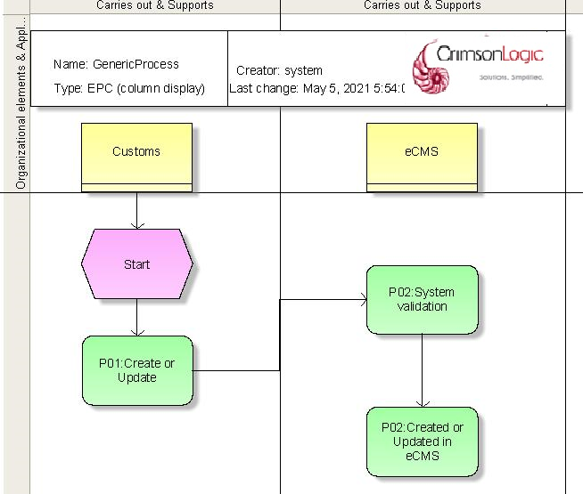

Process Steps
P01: Create or update Tariff Codes
Customs Officer will create the codes like CPC, Tax types, Chapter, Heading, Sub heading and HS code.
P02: System Validation
System will validate for any data issue, duplication etc.
P03: Create or Update in eCMS
The codes will be created or updated in eCMS system.

HS Code Maintenance

Description

The HS Code format followed in eCMS is as per recommended by WCO. It comprises of 8-10 digits. The 8-chars are for chapter, heading, sub-heading & HS Code. The last 2-digits are for country specific classification. The Chapter Code is the initial part of the HS Code to classify goods. This is a 2-numbered code that specifies a broader classification. For example, the Chapter Code ‘10’ is used to represent all metallic objects.

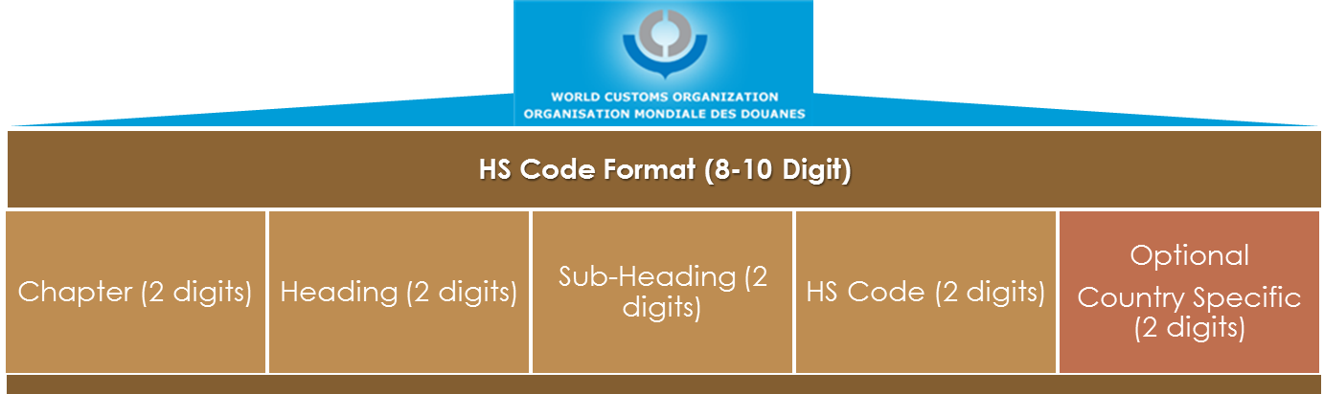
Heading Code is a 4-numbered code where the first two digits refer to the Chapter, and the last two digits as the Heading position in a HS code. These represent additional classification. For example:
- Chapter 10 – All Metals
- Heading 1001 – Gold Metal

Sub heading code is the 6 digits comprising of the chapter, heading and a further sub-division of the heading by 2 digits. HS Code is an 8-digit international nomenclature system.
Example:
To represent a 24-carat gold, the HS code can be 10010001, where:

10 is the Chapter Code to represent all metals.
1001 is the Heading Code to represent a specific metal (here Gold)
10010001 is the HS Code to represent a 24-carat gold to be measured in KGM (Kilogram)

Section will be created and linked to the chapters. There are around 18 sections defined in the system. Every chapter will be linked to section available in the system for the view purpose. However, this will not be used as part of HS Code. HS code will be considered from chapter onwards in declaration and tax configuration.

Design Considerations

S/N | Validation Rules
2 | Each HS Code can have 1 Unit of Measurement (UOM) assigned to it. During declaration submission only these configured UOM can be used.
3 | The system should have the capability to extend the HS code to 10 digits.  10 digits of HS Code consists of Chapter Code (2 digits), Heading Code (2 digits), Sub Heading Code (2 digits) and HS Code 4 Code (4 digits).

Use Case Diagram for HS Code maintenance


HS Code Maintenance

Customs Officer

Create Chapter

Search Chapter
Update Chapter

Create Heading

Search Heading
Update Heading

Create Sub- Heading

Search Sub- Heading
Update Sub-Heading

Create HS Code

Search HS Code
Update HS Code

Tax Types

Description

Tax Types define a complete list of all tax types applicable in the country, such as Customs Duties, Consumption Tax, Luxury Tax, Goods and Services Tax (GST), Green Tax (GRT), Surcharges & any other charges. It forms the line item in the duties and taxes computation. The following are the configurable fields defined at the tax type level:

Field | Description
Tax Type Code/Name | Unique identified for the tax type
Validity Period | Defines the period when the tax type is valid
Item/Header Level Indicator | To indicate if the Tax Type is at the Item level or Header level
Fixed Tax Indicator | This is to indicate if this is a fixed tax (or fees) for a particular CPC/CPC Group. For example, if there is a fixed Transit processing fee, then it will be indicated as “Fixed”. If it is not fixed, then it will be based on the tariff HS Code selected
Tax Rate | - Ad valorem – a percentage of the value  - Specific – based on a specific unit of measurement for e.g., $5 per box of an item.  - Derived – Based on the customized rate for specific INCOTERMS for e.g., 2% of Cost. Or 2% of cost and 1% of insurance.
Tax Rate Validity Period | Defines the period when the tax rate is valid
CPC Group | To specify if the tax type is applicable only to certain CPC groups / regime.

Ad Valorem

The ad valorem tariff type has the below configurations:

Rate Types | Description | Additional Configurations
Cost Base | The cost base used to compute the base value for which the Ad valorem is applied | FOB or CIF or FOB + Any combination of Freight, Insurance and Other Costs
Derive Cost Base From | The cost base is derived from any of the following. | - Derive rate from Tax Type – The ad valorem rate is taken from the tax type and not HS Code level  - Derive cost from Tax Type – The cost base is taken from the tax type and not HS code level.  - Has Additional Taxes – This indicates if there are additional taxes i.e. GST.  - Derive cost from HS Code – The cost base is taken from the HS Code. The one in Tax Type will be ignored.

Specific Rate

The specific rate tariff type has the below configurations. If the HS Code has UOM for e.g., milk can have UOM as Liter then the specific rate can be defined as UOM.

Rate Types | Description | Remarks
Rate Amount | The amount per UOM | For e.g., $10 per -litre
Rate Currency | The currency for the rate amount
Rate Unit | The unit’s name | In above case unit name is “-litre”
UOM ID | The Unit of Measure | In above case it is the litre

Derive Cost

The customs value (defined as cost here) is based on CIF or FOB etc. as described above in ad valorem section. In addition to this, eCMS provides for flexibility where the user can define different tariff rates at each of the component of the INCOTERM. For e.g., instead of a flat rate of 5% on CIF (as customs value), the user may choose to define 5% on Cost, 4% on Insurance and 2% on Freight. This will give customs the flexibility to rationalize & accurately apply duty for products whose value is less, but freight may be higher.

Additional Tax (Derive Tax)

In addition to the 3 methods illustrated above (i.e., ad valorem and specific), eCMS provides a flexibility where the user can combine different tax types to derive a tax. For e.g., if GST has additional tax on the Customs Duty Rate (CDR) and Green Tax Rate (GTR), system will take the computed value of CRD and GTR and apply configured 10% of GST tax on the computed Customs Duty Rate (CDR) and computed Green Tax Rate (GTR).

Use Case Diagram for Tax Type maintenance


Tax Type
Create Tax Type
Update Tax Type
Customs Officer
Search Tax Type

HS Code Configurations

Description

Each HS Code has tariff & tariff related configurations in order to calculate the duty of that particular item declared in declarations. The computation done at the HS Code level will be part of the item level taxes.

The tariff configuration for the HS Code comprises of the following types of tariff:

- Ad-valorem Rate - Rate is defined in percentage of the items value (e.g., 5% of the item value)
- Specific rate - Rate is defined in the specific quantity of the items (e.g., 5 Dollars per 10 KGM). The UOM used for the specific rate should be same as the default UOM configured for the HS code. System does not handle the conversion between different UOMs.

Commercial Name

Each HS code should be configured with commercial names. This will help in understanding of the description of the HS code and commercial usage. One HS code can have multiple commercial names.

Unit of Measurement (UOM)

Each HS Code can have 1 Unit of Measurement (UOM) assigned to it. During declaration submission only this configured UOM can be used. This UOM can be used in the specific rate configuration for the HS code.

HS Code Tariff configuration
Each HS code can have more than 1 tax types assigned to it. These configured taxes will be read by system and duty computation will be performed during declaration submission.

Prohibited

Each HS code can be updated as prohibited in HS code maintenance. Once the HS code is prohibited, system will alert the user if the declaration the selected HS code is prohibited and cannot be used in Declaration module during submission of declaration.

Restricted Goods
Each HS code can be updated as restricted in HS code maintenance. During declaration submission, system will show the validation message to the user to upload the permit copy of the agency as attachment in supporting document section. We will configure a separate document type to be uploaded when the restricted goods are included as part of declared item i.e. HS Code

Customs Procedure Code (CPC) Maintenance

Description

A Customs Procedure Code (CPC) is used to identify the nature of the transaction being affected and indicates the details of the movement of the goods. CPC is composed of five digits where the first digit identifies the regime; the second digit identifies the previous regime (if applicable); and the rest are given by the officer.
Example
- Import for home use - 40001
- Import from warehouse for home use – 40701
  - 40 is import regime
  - 70 is warehouse regime
In addition to defining the nature of processing CPC, eCMS defines validation rules at CPC level which has impact on computation of duties and taxes. Below are the tariff related configurations:

S/N | Configurations
1 | Through the CPC, the system should be able to suppress any tax types, while it maintains the others, so the suppression is at Tax Type level.  For e.g., for Transit, the duties should be suppressed (Not Applicable) and only a Transit Fee should be charged.
2 | Tax Types applicable to certain CPC only, for e.g., Declaration Processing Fee is applicable to all Import related to CPC Groups. This may be configured at the tax type level.
4 | Precedent entry CPC (Previous CPC)

Use case diagram for CPC


CPC
Create CPC
Update CPC
Customs Officer
Search CPC

Agreements/Preferential Tariffs

Description

This is applicable when there are preferential agreements on the tariff that are based on common agreements or on any national preferential agreements or Trade blocs (e.g. SARC etc.
The preferential tariff is defined using the country groups or country list. The preferential tariff may be configured and associated with CPC. The configurations related to preferential tariff are as below:

S/N | Fields | Preferential Configurations
1 | HS Code/ Subheading/ Heading/ Chapter | Preferential tariff rate may be applied to specific HS Code or at the sub-heading, chapter or heading level.
2 | Rate Type | Can be ad valorem or specific.
3 | CPC | Preferential tariff may be applied to specific CPC only. For e.g. all imports by diplomats for a certain county are entitled for preferential tariff on certain goods.
4 | Tax Type | The tax type on which the preferential rate is to be applied.

Note: Bhutan is having bi-lateral agreement with Bangladesh. In this case, system will show only the preferential CPC in declaration if the added HS code is in preferential tariff list and country of origin is Bangladesh. We should be able to configure preferential tariff once the agreement is finalized, like Thailand and Nepal.

Use case diagram for Preferential Tariff


Preferential Tariff

Create Preferential Tariff

Search Preferential Tariff
Update Preferential Tariff
Customs Officer

Duties and Taxes Computation Process

Description

Duty computation in eCMS takes in account 4 major inputs i.e., HS Code, Tax Types, CPC & Preferential Tariff configurations. Based on these 4 key inputs the duties and taxes are derived at item level and declaration header level.
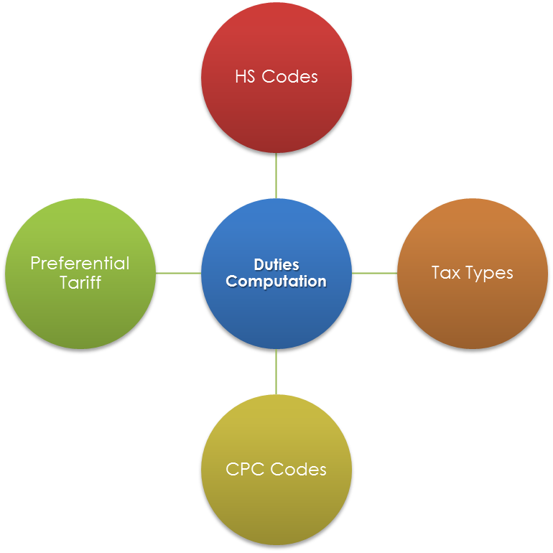

Computation Process

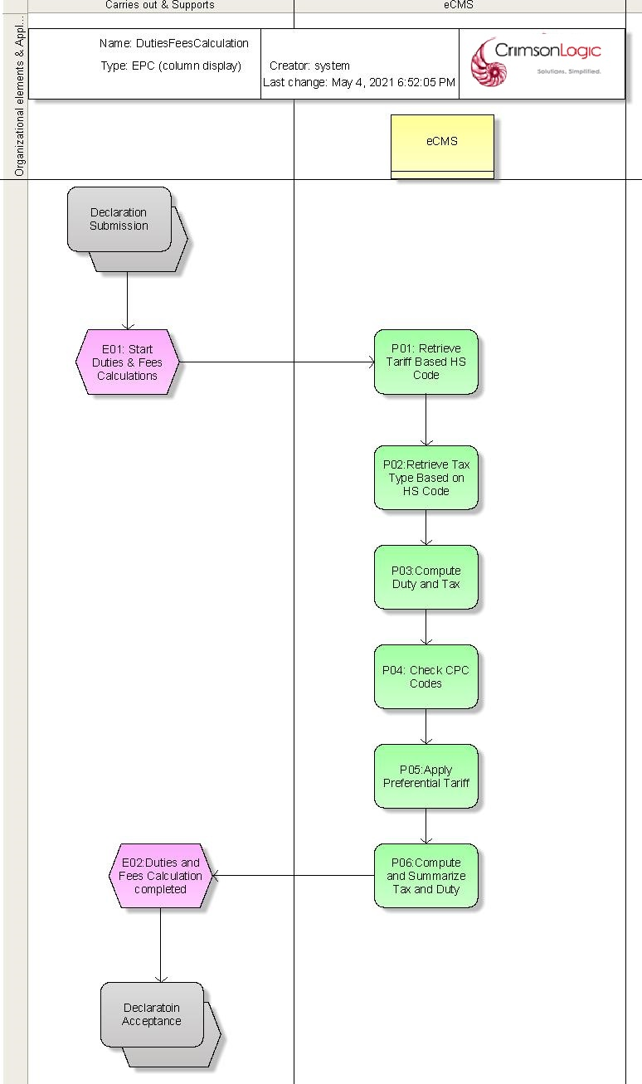

The process for Duties and Tax computation is shown below. The amount is computed for all items in the declaration in the same manner, and all tax line items are aggregated for final computation.

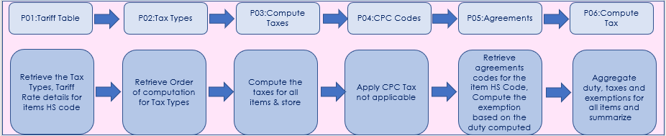

Process Steps
P01: Tariff Table
Retrieve the HS Codes for each item and the applicable tax types and tariff rates. The duty is computed based on the defined tariff rate.
P02: Tax Types
The order of computation is retrieved from Tax types of table.
Note: GST has to apply on top of the CDR, hence it has to be configured after the CDR tax order.
P03: Compute Taxes
If any of the amounts (FOB, freight, insurance, etc.) are in foreign currency, it is converted to the local currency first before the duty computation starts. The duties and taxes are always expressed in local currency.
Store the computed amount in the DB for reporting purposes.
P04: CPC Codes
Retrieve the CPC Codes at the declaration item level and all the CPC attributes.
Apply CPC level tax not applicable indicators, if any.
P05: Agreements
Declarant chooses the preferential tariff CPC for the item in the declaration. Retrieve the tax rates from the preferential tariff table, and then compute the preferential tariff from the taxes computed above.
P06: Compute Duties and Taxes
Compute the duty and tax with exemption for all the items in the declaration and aggregate.

Rebate & Exemption

There will be an option to create CPC with Rebate and Exemption where we can configure the tax which is rebated or exempted. System will pick up this configuration during declaration submission and applies the rebate or exemption taxes accordingly.

User should be selecting the appropriate rebate or exemption CPC while submitting either rebate or exemption declarations.
Example

Exemption CPC has to be selected to apply on right tax rate
  - GST alone
  - EET alone
  - GST & EET

Preferential CPC

There will be an option to create CPC for preferential tariff. System will fetch these preferential CPC in declaration submission based on provided HS code and country of origin.

Use Case Diagram for Duties and Taxes Calculation

Duties and Taxes Computation

Duties and Taxes Computation
System

Advance Rulings

Description

Any registered user must be able to apply for advanced rulings, which will incur an application fee. Customs must be able to issue notifications of advanced rulings, which must be sent to the applicant and then published on the Customs website. Customs must also be able to issue Demand Notices for application fees, which must be automatically sent to the revenue system for processing.

Process flow for application of Advance Rulings

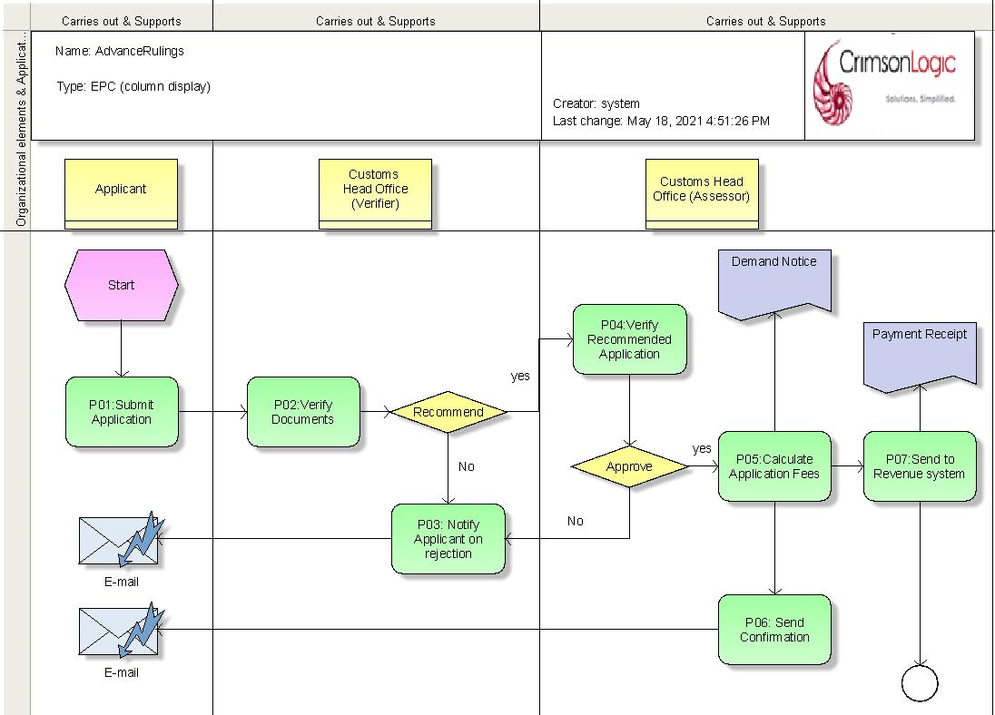

Process Steps
P01: Submit application
User must be able to apply for an advance ruling by completing an online application form. User can attach the supporting documents such as brochures, photographs of samples etc.
P02: Verify Documents
The verifier at customs head officer can verify the documents and recommend for approval or reject the application.
P03: Notify applicant on rejection
If the application is rejected, then system will notify the applicant by email notification with reason for rejection.
P04: Verify & Approve
The Assessor at customs head office will verify the application where he/she can either approve or reject the application. Mail notification with reason of rejection will be triggered in case of rejection by Assessor. Once approved, advance ruling has a validity period of 2 years. A notification will be issued to applicant. Customs Officer has to publish the new advance ruling on customs website (i.e. Notice and update). BTC code in tariff module must be updated with advance ruling details i.e. commercial name.
P05: Calculate the application Fees
If the application is approved, system will calculate the application fees based on below factor.
- A base fee of Ngultrum 500 to a maximum of 10 commodities.
- Additional fee of Ngultrum 100 per commodity that exceeds the maximum limit of 10 commodities.
P06: Send confirmation
A confirmation mail notification will be shared to applicant upon approval of the advance ruling.
P07: Send to Revenue system
The payment information shared to revenue system. The revenue system will return the details of receipt to the eCMS once payment has been made.

Note: System will insert the commercial names for HS code once the advance ruling is approved. There will be a start and end date for that approved commercial name and linked to the advance ruling which belongs to.

Process flow for Revoking Advance Rulings

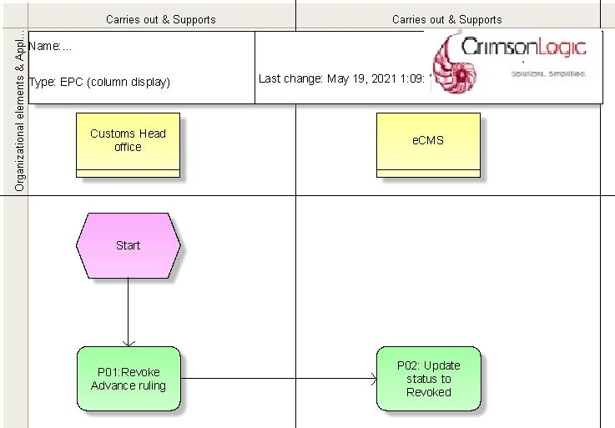

Process Steps
P01: Revoke by Customs
Customs officer should have an option to search and revoke the approved advance ruling. Officer opens the advance ruling and update the status to be revoked.
P02: Update status to Revoked
The eCMS system status will get be updated the advance ruling as revoked. Customs Officer has to publish the revocation in customs website (i.e. Notice and update).

Note: If the advance ruling is revoked then corresponding commercial name will be expired in tariff module and that will not be available in declaration submission after the expiry date.

Use Cases of Advance Rulings



Advance Ruling
Submit Advance Ruling
View/Update Advance Ruling
Search Advance Ruling
Applicant
Approve/Reject Advance Ruling
Customs Officer
Revoke Advance Ruling

Appendix A

Configuration blueprint (CBP)

Configuration Blueprint (CBP) for Tariff

